Cp.gpswox.com

How often should I call API to get data?

Do you have any documents that explain about API?

# Device API

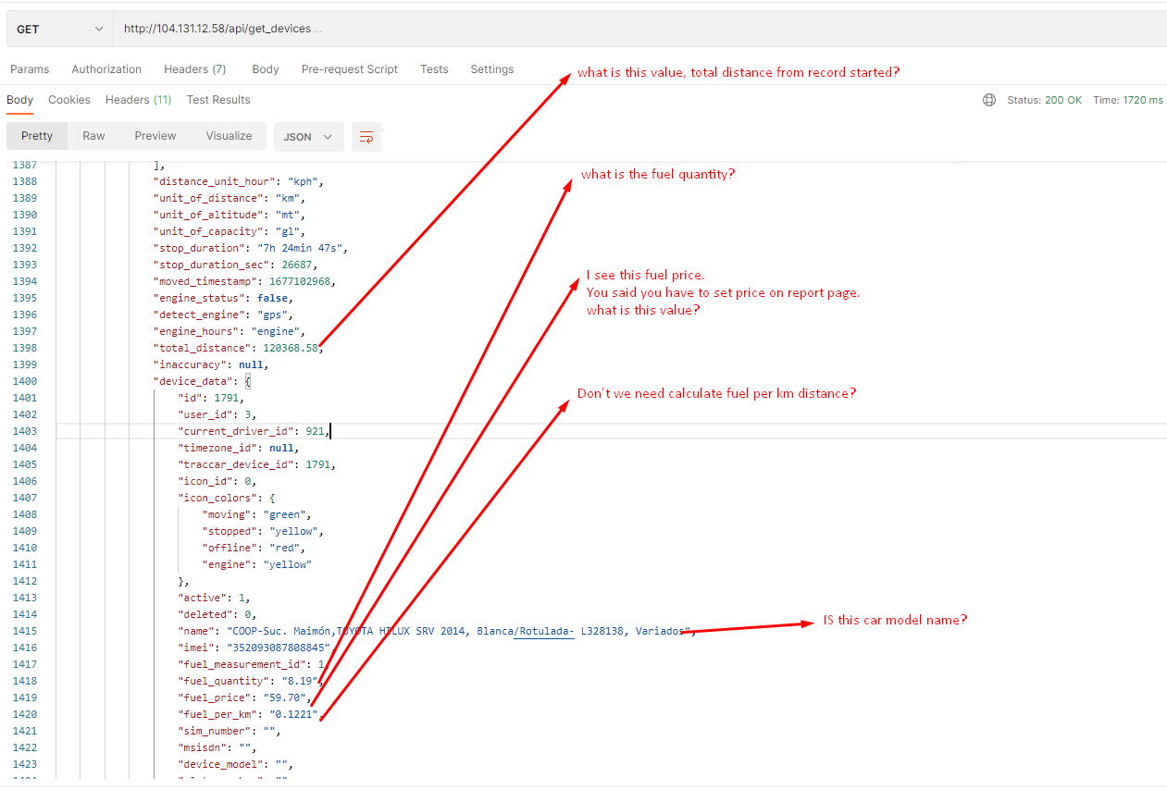

# History API

I have tried to get history using API

Let me know the example of these values

What is the device id?

Format of date and time?

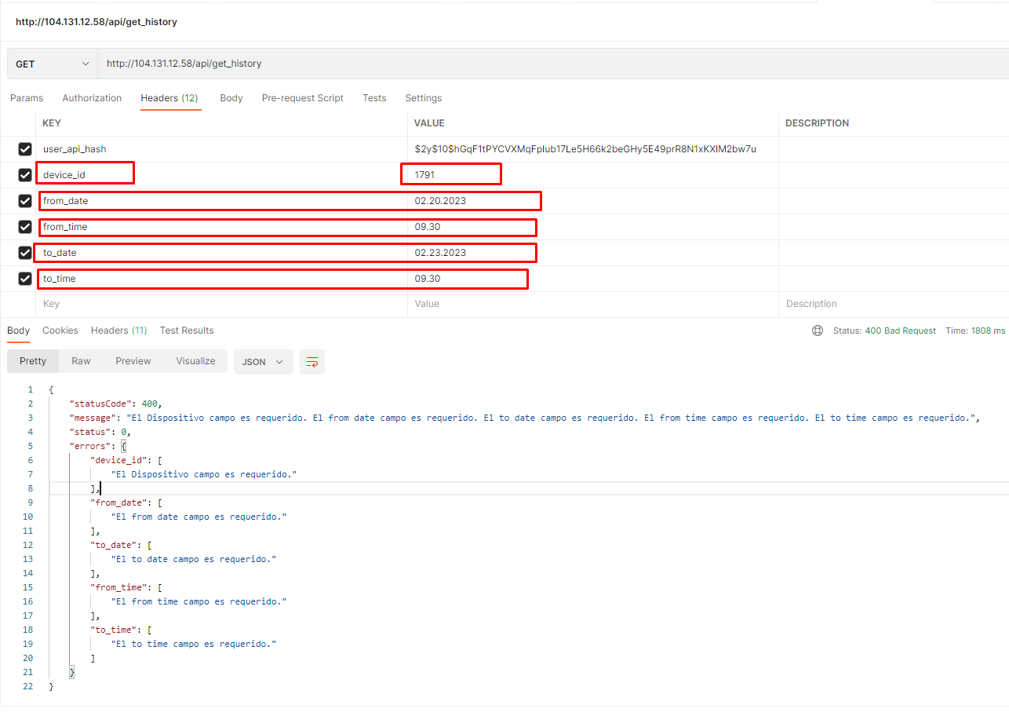

I also tried like this

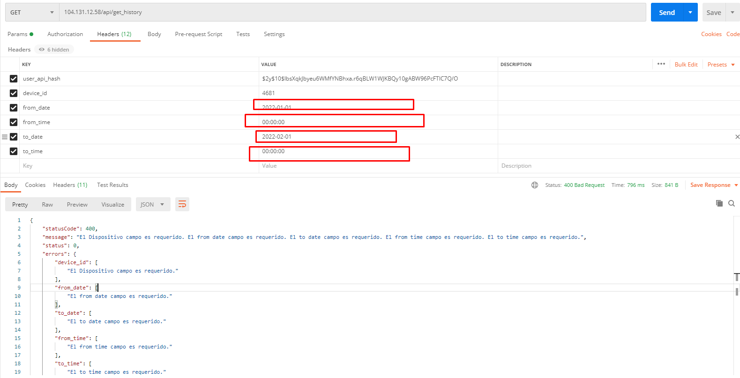

What’s wrong?

If you let me know about above values, I can get history messages too

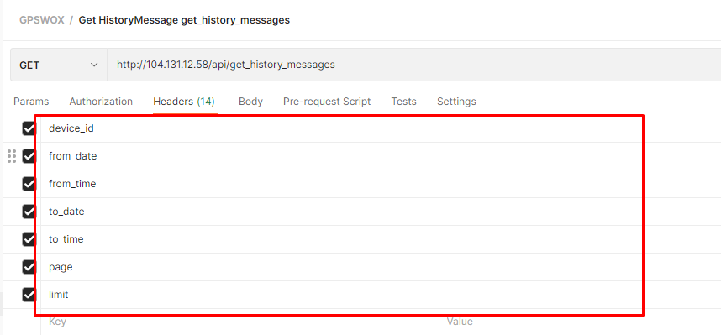

# Sensor API

I think I don’t need research these API

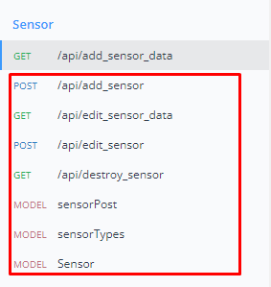

I have tried to get list of sensors

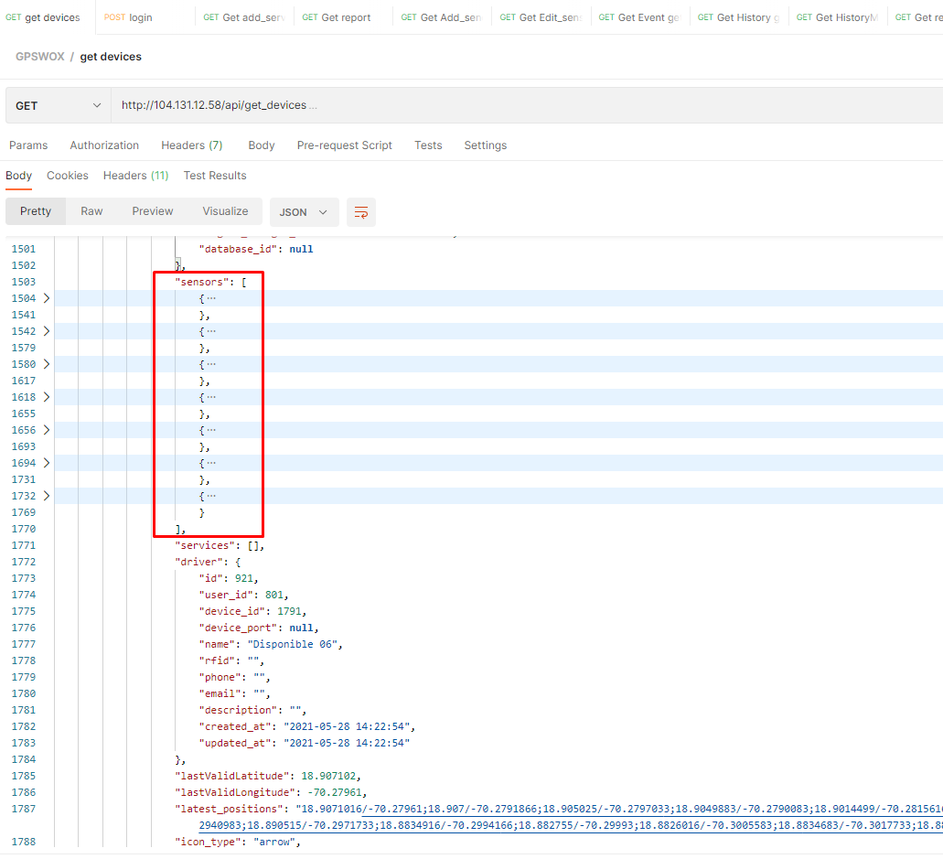

There are many sensors, which sensor return temperature values?

# Report API

I have tried to get reports type

API is this

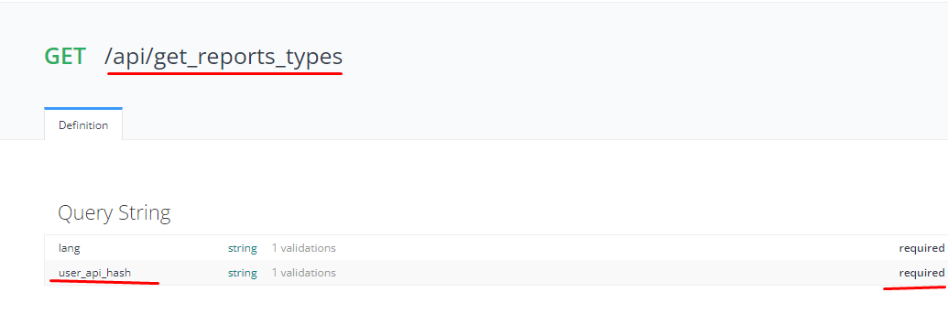

What’s wrong on my API call?

Why this API retrieve data on “user_map_icons” table?

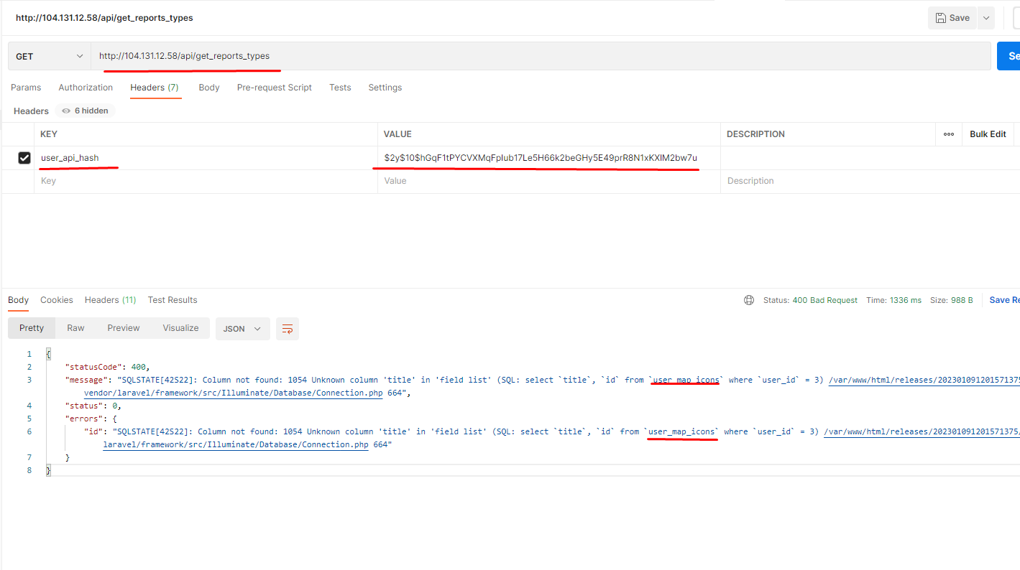

Can I get reports types like this?

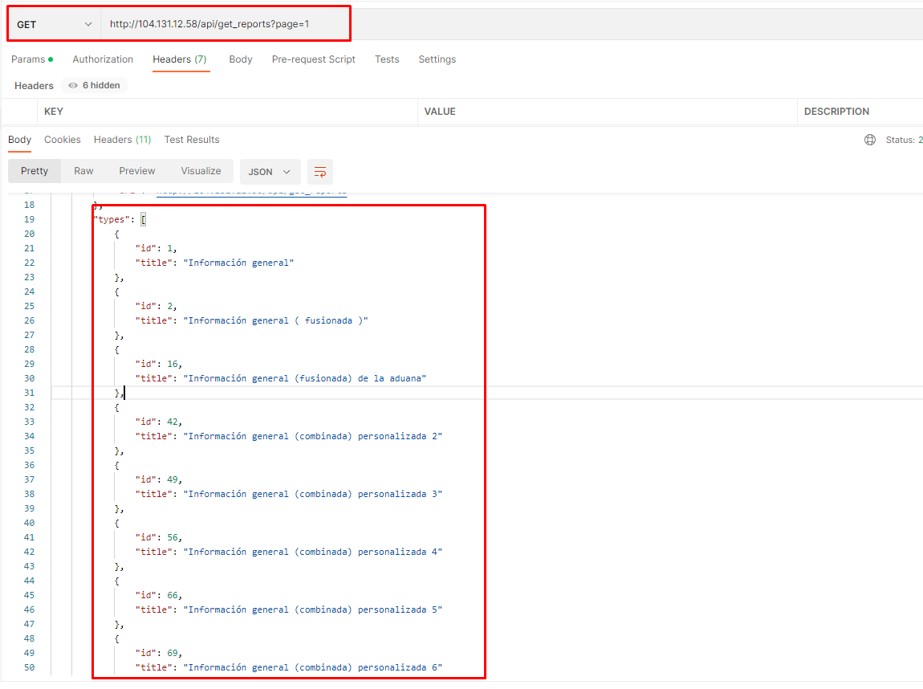

# Event API

I have tried to get events using this API

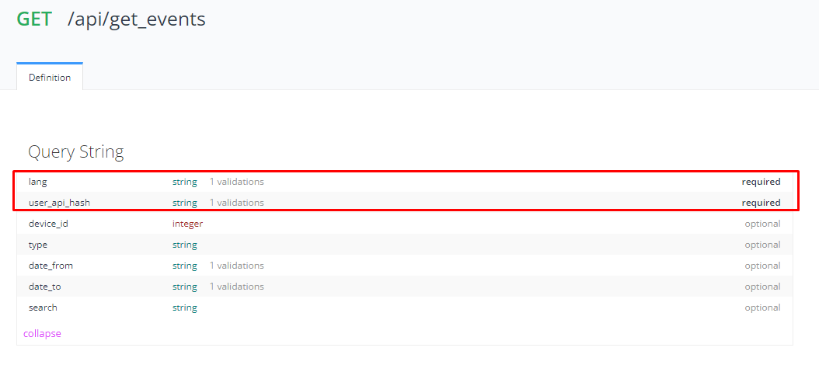

But got this return

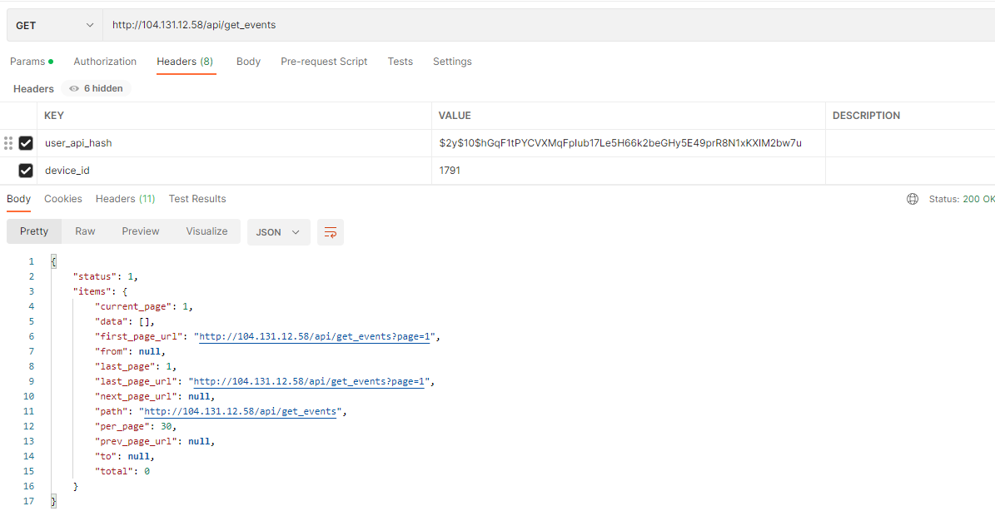

What’s wrong?

Alert API

Driver API